4KW Diesel Parking Heater
Technical Description, Installation, Operation and Maintenance Instructions

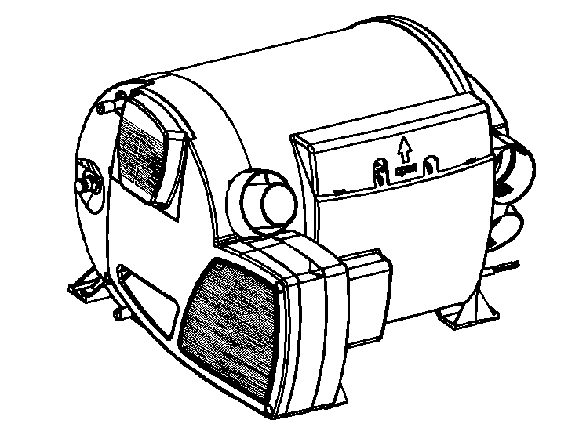

Production Type Order No
Diesel electric DC12V/220VAC 4W2005 12C11

Version:Apr.25,2019

Foreword
Thank you for using our parking heater
This manual describes the technical description, installation, operation and maintenance instructions for the parking heater. To ensure the correct use of the heater please read this manual carefully before installation and use. Please keep it properly after reading it. For review.
Note:
  - The contents of this manual are subject to change without prior notice, but the instructions are guaranteed to be consistent with the products purchased.
  - we try our best to express the problems that users should know through the instructions. If you have questions or find something wrong, please contact us directly.
  - When the user unpacks for the first time, check the main unit and accessories against the packing list. If you find any problems, please contact the dealer immediately.
  - If there is a problem in use, please contact the company's marketing department or our authorized customer service station. We will be happy to help you.
Please carefully save the after-sales service warranty sheet and provide feedback as required. This sheet is the only valid proof of after-sales service.
Note:
Must be installed and used in accordance with the requirements of the manual to ensure long-term use of the product!

20190425 Edition Subject to Change

1.Application
FJH-4/1C-E Model air parking heater (hereinafter referred to as heater) is a special heater for caravan that integrates hot water and warm air. This heater cannot be used in bus or dangerous goods carriers.

2. Main Technical Data
Rated Voltage | DC12V  12V/24V
Operating Voltage Range | DC10.5V～16V
Short-term Maximum Power Consumption | 8-10A
Average Power Consumption | 1.8-4A
Fuel type | Diesel
Fuel Heat Power (W) | 2000 | 4000 |  | 5000
Fuel Consumption (g/H) | 220 | 440 |  | 550
Quiescent current | 1mA
Warm Air Delivery Volume m3/h | 287max
Water Tank Capacity | 10L
Maximum Pressure of Water Pump | 2.8bar
Maximum Pressure of System | 4.5bar
Rated Electric Supply Voltage | ～220V
Electrical Heating Power | 900W  柴油 |  | 1800W
Electrical Power Dissipation | 3.9A |  | 7.8A
Working (Environment) Temperature | -25℃～+80℃
Working Altitude | ≤1500m
Weight (Kg) | 15.6Kg（without water）
Dimensions (mm) | 510×450×300
Protection level | IP21

Table 1

3.Function

The heater is a hot water and warm air integrated machine, which can provide domestic hot water while heating the occupants. This heater allows use during driving. This heater also has the function of using local electricity heating.

In hot water warm air work mode, this heater can be used to heat both the room and the hot water. If only hot water is needed, please choose hot water working mode.

When the ambient temperature is below 3°C, please empty the water in the water tank to prevent freezing of the water tank.

There are three energy options to choose from:

-- Diesel Mode

Heater automatic adjust the power.

-- Electrical Mode

Manually select the 900W or 1800W heating mode according to the power supply capacity of the RV camp site.

-- Hybrid Mode

When the power demand is low (for example, maintaining the room temperature stage), the electrical heating is preferred. Until the city electricity cannot meet, the diesel heating is started, and the diesel heating function is turned off first in the power adjustment phase.

In hot water working mode，gas mode or electrical mode is used to heat the tank。The tank temperature can be set to 40°C or 60°C.

-- Diesel Mode

The heater operates at the lowest power. Stop heating immediately after reaching the set temperature.

-- Electrical Mode

Manually select the 900W or 1800W heating mode according to the power supply capacity of the camp site.

4. Safety work environment
-- The device can only be operated with appropriate control panels and accessories
--Danger of toxic exhaust fumes.The heater’s exhaust can be toxic in enclosed spaces(e.g.garages,workshops).If the vehicle is parked in closed rooms:Shut off the fuel supply to the heater、Deactivate the time switch、Switch off the heater at the control panel.
--If the cowl has been placed near or directly beneath an opening window,the appliance must be equipped with an automatic shut-off device in order to prevent operation with the window open.
--Heat sensitive objects(e.g.spray cans)or flammable materials/liquids must not be stored in the same compartment where the appliance is installed because nunder certain conditions,this area may be subject to elevated temperatures.
--The openings for circulated air intake,the installation compartment and the space around the unit must be kept free of obstacles so that the unit does not overheat.
--Keep the cowl for the exhaust duct and combustion air intake free of contamination(slush,ice,leaves etc.)at all times.
Danger from hot surfaces and exhaust gas.Do not touch the area around the wall cowl and do not lean any objects against the wall cowl or the vehicle.
Obligations of the operator/vehicle owner
--The operator is responsible for the water with which the boiler is filled and for its quality.
--The vehicle owner is responsible for correct operation of the appliance.
--Liquid fuel system must comply with the technical and administrative regulations of the respective country of use.The national legislation and regulations must be observed.
--Pressure regulating devices and hoses must be replaced with new ones no more than 10 years after their date of manufacture(every 8 years if used commercially).
--Inspect hose lines regularly and have them replaced if they are broken.
--If the heater is not being used,always drain off the water if there is a risk of frost.NO claims may be made under the warranty for damage caused by frost.
Safe operation
--The flow rate of the pressure regulating equipment must correspond to at least the maximum consumption of all devices installed by the system manufacturer.
--Ensure that the inside of the vehicle is sufficiently ventilated when the unit is started up there may be some smoke and /or smell due to dust or dirt.Especially if it has not been used for a long time.
--This appliance can be used by children aged 8 and over,as well as by persons with reduced physical.
--The integrity and tight fit of the exhaust double duct must be checked regularly,particularly at the end of long trips.Also check the mounting of the unit and the cowl.
--When cleaning the vehicle,do not spray water directly into the cowl.

5. Heater installation
The typical installation of the heater is shown in figure1.
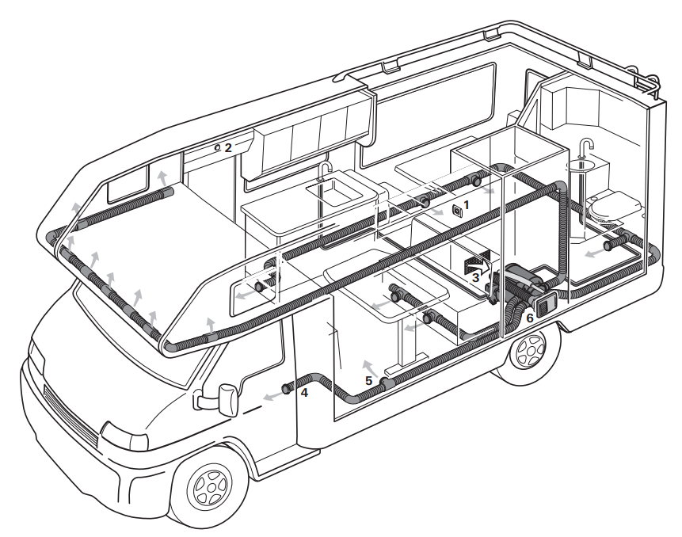

Figure 1

1-LCD control switch
2-External temperature sensor
3-Recirculating air inlet (minimum 150cm2)
4-Heat pipe
5-Heat outlet
6-Smoking cowl

★ Must be installed and repaired by professionals authorized by the company!

The company does not bear any responsibility for the following acts:

--Modified heater and accessories

--Modification of exhaust lines and accessories

--Do not follow the operating installation instructions

--Do not use our company's special accessories
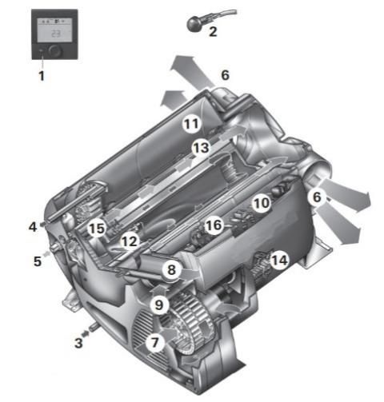
1-LCD switch 9- Combustion air inlet
2- External temperature sensor 10-Electronic control unit
3-Cold water inlet 11-Water container
4-Hot water outlet 12-Burner
5-Fuel connection 13-Heat exchanger
6-Warm air outlets 14-Power electronic
7-Circulated air intake 15-Heating elements
8-Exhaust discharge 16-Overheating switch
Figure 2

Heater installation Figure 3.

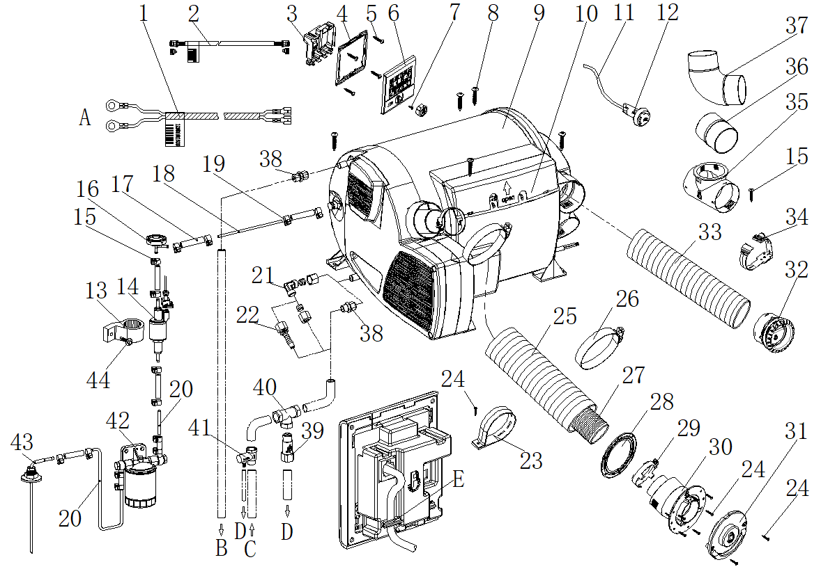

1_12V Power cord 2_ LCD switch Lead wire 3_ LCD switch back cover 4_ LCD switch bracket 5_ Self-tapping screw M3*10 6_ LCD control switch 7_ Cross countersunk head flat tail self-tapping screw M3*6 8_ Self-tapping screw ST5*25 9_ Heater 10_ Controller cover 11_ External temperature sensor lead wire 12_ External temperature sensor 13_Fuelpump connector 14_Fuel pump 15_Fuel pipe clamp(φ9-11)16_Damper 17_Fuel pipe connector 18_6-Fuel pipe（trsparent,from heater to fuel pump）19_Fuel pipe clamp(φ8-10)20_ Fuel pipe（blue,from fuel tank to fuel pump）21_φ10 Steel (water) pipe elbow transition fitting
22_ Hose(water) transition fitting 23_ Intake pipe mounting clamp 24_ Self-tapping screw ST3.5×25 25_ Air intake pipe 26_ German type clamp 27_ Exhaust pipe 28_ Sealing rubber spacer 29_(Exhaust pipe) clamp 30_ Intake and exhaust combine cowl31_ Intake and exhaust combine cover 32_ Air outlet 33_ Hot air ducting 34_ Ducting clamp 35_φ60T-pipe 36_φ60connector 37_φ60 Elbow 38_ G1/2-φ10 Ferrule fitting 39 Frost valve 40_ G1/2 T pipe 41_ Reducing valve 42_Filter 43_Fuel suction pipe 44_Self tapping self drilling screw ST5*30
A_ Connect to 12V Battery B_ connect to water equipment C_ connect to system water tank
D_Flow out of the car E_ Hook，clamp LCD switcher cord

The heater installation location should be selected from load-bearing floor, double floor or underfloor.

If there is no suitable floor, you can first make a load bearing surface with plywood.

★The heater must be firmly fixed to the mounting surface with

Figure 3

screws to prevent damage to the gas pipeline during driving and cause danger.

Depending on the actual installation, may only install three screws. Two die-cast aluminum fixing screws are fixed then choose a plastic right angle to fix it.

To ensure that the heater evenly distributes heat, the heater should be installed in the center as much as possible to ensure that the heating circuit is equal long as possible.

No cover is allowed to add to the heater surface.
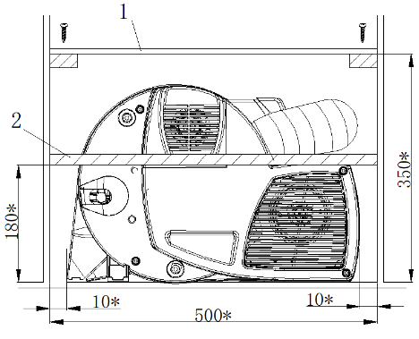

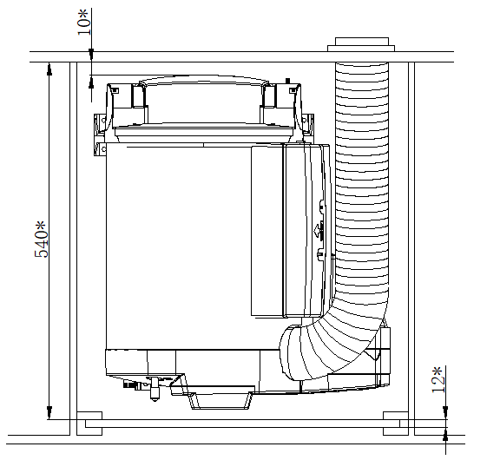

Figture.4
The size with* is the smallest size, leaving enough space to connect accessories such as gas and water pipes.
To prevent the danger from heater accidentally loosening, the upper cover of the heater compartment is screwed to the upper cover (Figure 4-1). Next to the installation location it is necessary to install a strong partition strip in front of the heater, perpendicular to the direction of travel. Above the floor height180mm can be attached to a septum (minimum 30*50mm).
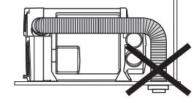
Heat sensitive objects and flammable objects should be placed away from the heater.

Figture.5

★ The exhaust cowl must be on the side wall or ceiling.
In the exhaust cowl installed area， there is no ventilation window in the range of 300mm, and there is no refueling port or tank respirator in the range of 500mm.
The exhaust cowl is mounted below the window that is close to or operable. A window switch should be installed to ensure that the heater is turned off automatically when the window is opened.
Air Inlet Hose Installation
The exhaust pipe is passing through the intake pipe.
The length of the intake and exhaust pipe is as shown in Fig. 6, and the shortest is 60cm and the longest is 100cm. The exhaust cowl is only allowed under the exhaust outlet 20cm.
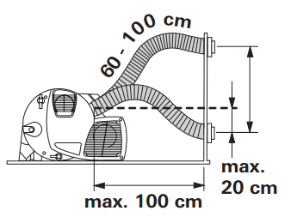

Figure.6

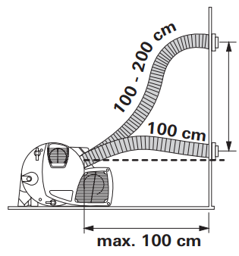
After the intake and exhaust pipes are pierced from the through holes, they must be cut short, and the exhaust pipes are slightly shorter than the intake pipes. Avoid excessive expansion or tension on the exhaust pipe

Figure.7

The length of the intake and exhaust pipes is 100 cm to 200 cm, as shown in Figure 7. The piping must be arranged in the ascending direction.
The Exhaust Cowl （air inlet and outlet） Installation
Select a flat mounting surface so that combustion air can enter from all sides. Drill one hole of φ83. Seal (Fig. 8-8), with the plane facing the exhaust cowl. Wear the fixing clip before installing the exhaust pipe (Figure 8-3). Pay attention to the installation of the smoke cap upwards.
20mm at the end of the exhaust pipe should be compressed, do not straighten. Insert the exhaust pipe into the exhaust cowl interface（Figure 8-10），as deep as possible. Try to fix the clips on the top, tighten.
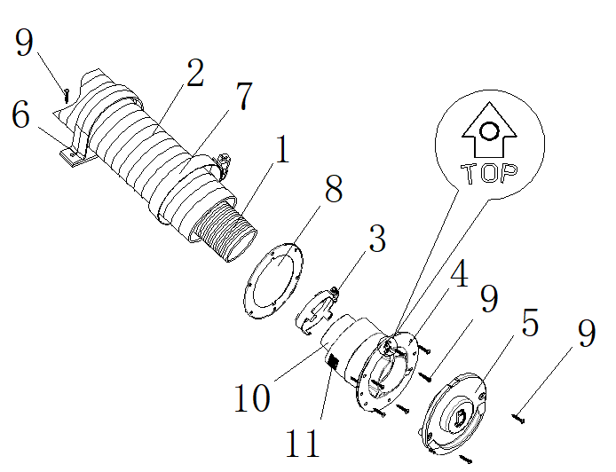
Figture.8
Place the air intake pipe (Figure 8-2) over the exhaust cowl tooth (Figure 8-11). Set on the fixed clip（Figure8-7）, tighten.
Secure the exhaust cowl with 6 screws (Figure 8-9). Use 2 screws to fix the exhaust cowl.
Fix the exhaust pipe on the side wall with mounting clip.
Connect Air Inlet Pipe to The Heater
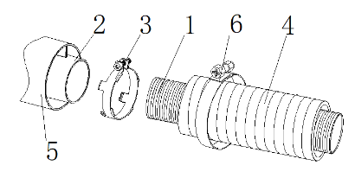
Figture.9
20mm at the end of the exhaust pipe should be compressed, do not straighten.
Try to insert the exhaust pipe on exhaust port as deep as possible。fix the clip on top, tighten.
Place the air intake pipe (Figure 9-3) over the air inlet port (Figure 9-5). Set on the fixed clip (Figure9-6）, tighten.
Warm Air Intake
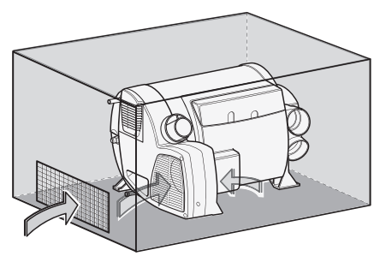
Figture.10
The warm air intake is drawn in by the heater. There must be a total area between the room and the heater not less than 150cm2 opening.
Ensure that the warm air intake is not contaminated by the engine or heater exhaust, if necessary, with structural isolation measures.
Warm Air Distribution
Most of the warm air is imported into the floor area of ​​the living compartment through the bellows.
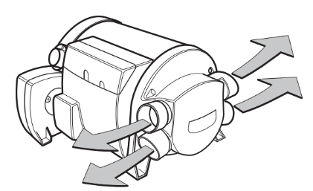

Figture.11
The four air outlets on the heater are connected to the φ65 bellows. Use only pressure piping that meets the quality requirements of the Belief. Other pipes that do not meet our quality standards (especially wind resistance, pipe diameter and number of ripples) shall not be used. If the warm air duct must withstand a considerable amount of bending immediately after the hot air outlet of the heater in a limited space, we recommend using a 90° elbow (Figure 3-37). This elbow can be connected to a diameter of 65
mm hot air duct.
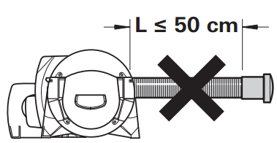

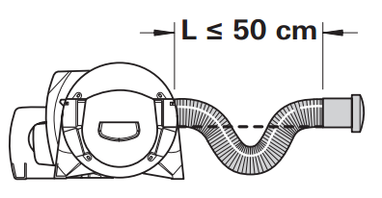

Figure.12
In the case where the length of the pipe is less than 2 meters, the air outlet cannot be installed at a height higher than the connection of the warm air duct. When the pipe length is less than 50cm, the pipe must be siphon between the connector and the outlet. These measures prevent the undesirable heating caused by (fairing effect) convection of the vehicle during summer operation.
Fuel tank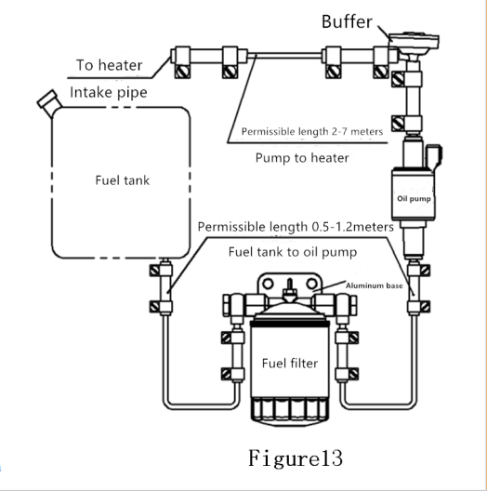
★The warm air pipe must be firmly inserted into the connection port.
To get the best warm air distribution, Belief recommends using 4 warm air outlets for the heater.
If only three warm air outlets are required, then a lower warm air outlet must be selected to seal.
★ The cross section of the heater duct must not be reduced due to pipe connections or the analogue.
In other words, no less than four warm air outlets (figure 3_32) are opened. Make sure that more than four warm air outlets are opened.

Fuel system connection
The fuel is extracted from the vehicle fuel tank or supplied from the 10L special fuel tank. The fuel is transferred and the fuel supply is adjusted through the special fuel pump (provided by the manufacturer).Fuel extraction from the vehicle engine return system or downstream of the vehicle internal delivery pump is not permitted. Please install only the fuel hose and piping within the delivery range.
The fuel shall meet national standards
GB19147-2013 diesel standard for vehicles
Winter fuel should meet the low temperature requirements brand, do not allow the use of biofuels.
Fuel line system
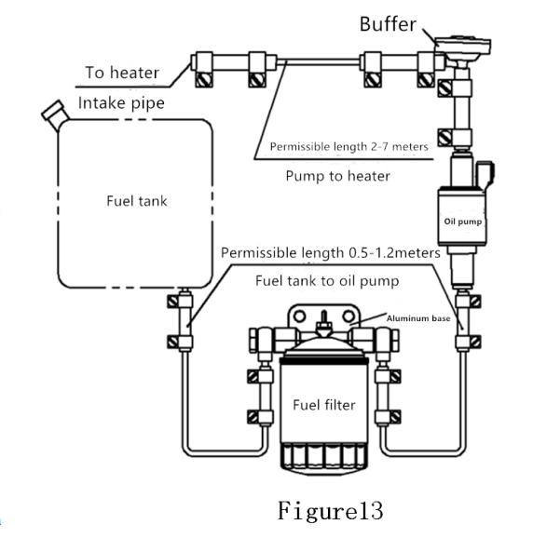
Installation of oil pipe
Only the flexible nylon pipe, which has good light-resistance and thermal stability, supplied with the heater can be used as the fuel pipe. Allowable length of fuel line: the maximum length of fuel line on the inlet side is 2 meters, and the maximum length on the pressure side is 6 meters. As shown in figure 13.
Safety Regulations for Fuel Pipe
Use a hose cutter or sharp cutter to cut the fuel hose and pipeline into a certain length. The cut area cannot be compressed and must be free of burrs. Fuel pipelines must be firmly connected to prevent vibration-induced damage or noise (the recommended distance between connecting points is about 50 cm). Fuel pipelines must be protected from mechanical damage. The laying of fuel pipelines will not adversely affect the stability of vehicle rotation and engine operation. Protect fuel-carrying parts from high temperatures that may affect operation (use appropriate glass fiber lined aluminum thermal protection hoses). Do not install or fix fuel lines near the exhaust pipes of heaters or vehicle engines. If the lines are crossed, keep enough distance from the thermal components - provide a thermal radiation shield if necessary. Pipe installation should be able to prevent flying stones from hitting, and keep away from heating parts of vehicles. Protective devices should be installed when necessary.
Installation of oil pump
The oil pump shall be fixed with a fixed jacket (rubber) of the oil pump. The outlet of the oil pump should be inclined upward, and its installation angle should be selected in the range of 15- 35 as shown in Figure 14. When conditions permit, the tubing between the pump and the heater mainframe should gradually rise. In order to prevent the oil pump from being heated (the maximum operating temperature is 40 C), do not install it near the exhaust pipe.
The height difference between the fuel level and the oil pump, and the height difference between the oil pump and the main engine inlet, will generate pressure (or suction) in the oil pipeline, so these dimensions should meet the requirements of Figure 14 (negative pressure will occur in the closed tank, when the minimum liquid level of the tank is required to be no more than 0.4m).
Connection between heater and oil pump The pipeline from the oil pump to the main engine should go up as far as possible. Mark the appropriate position on the floor of the vehicle for passage the hole of the fuel pipeline and the oil pump connecting the cable. Before drilling, pay attention to check the hidden cable, fuel pipeline, frame section, etc.
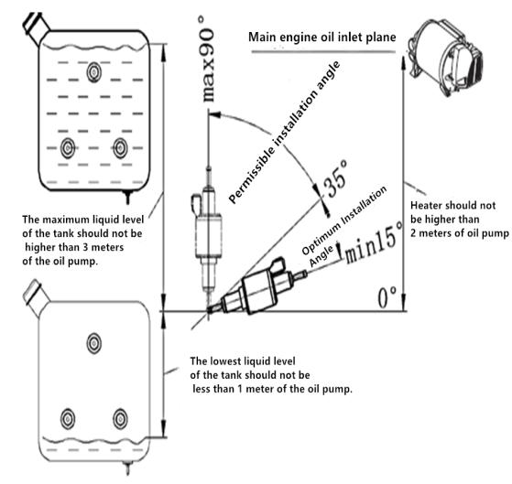
Figure14

The lower body protection device is then used to seal the edges of the openings on the floor of the vehicle. In order to prevent the cable between the tubing and the oil pump from being cut, please add the lead-in bushing or section edge protection material. The tubing should be bundled at the appropriate place for fixing, and the bundling distance is not more than 50 cm.
Connections between tubing and oil pump, main engine and oil tank (oil intake nozzle) shall be made by using tubing joints matched by this unit and using oil. The pipe clip is clamped tightly. Prevent bubbles from forming at the junction (Pic. 15).

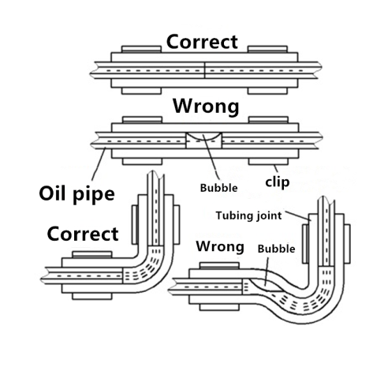
Figure 15

Installation of Fuel Filter
Install the fuel filter before the oil inlet of the oil pump. When installing, it should be noted that the fuel filter must be vertical upward (to ensure that impurities deposit downward). Fuel filter replacement cycle for two years, tubing connection head and clip must be replaced at the same time.
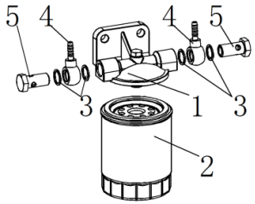
Figure16
1- Fuel filter aluminum base
2- Fuel filter
3- Sealing gasket
4- Articulated hose joint
5- Articulated bolt

Installation of oil intake nozzle (Pic17)
Firstly, the oil intake nozzle is fitted with O-ring, and then it passes through the bottom hole (self-processing) through the inside of the tank. Put gaskets on the outside of the tank and tighten them with nuts. The tightening torque is 6Nm+1Nm. The O-ring must be clamped between the inner wall of the tank and the oil intake nozzle to ensure good sealing between the oil intake nozzle and the oil tank. (Accessories such as oil intake nozzles are attached to the tank)
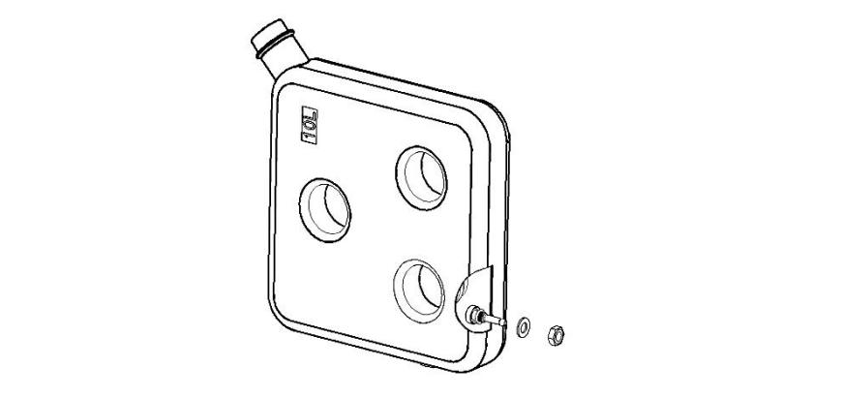
Oil intake nozzle
O ring
Washer
Nut
Figure 17

Installation of suction pipe（Pic21）
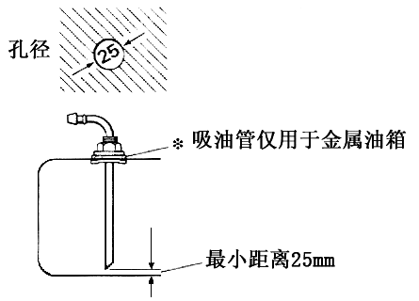
Use when drawing fuel from the fuel tank of the vehicle itself. When installing, attention should be paid to the size of the installation hole on the tank (or the cover of the tank) is 25 (+0.2), the edge is neat and the surrounding is smooth, so as to ensure good sealing between the suction pipe seat and the tank. The distance between the bottom of the suction pipe and the bottom of the tank should be 30-40 mm, which can not only ensure the full absorption of fuel, but also prevent the deposition of impurities at the bottom of the tank from being inhaled.
Figure18
aperture

Suction pipes are only used in metal tanks

Minimum distance 25 mm

The connection of water pipe
A pressure pump or submerged pump with a pressure of 2.8 bar can be used to supply water to the water tank. If the water tank is connected to a centralized water supply (rural or urban connection), or if a high-pressure pump is used, a decompress or must be used, which will prevent pressure above 2.8 bar.
★Before the relief valve is triggered, the temperature rise and expansion of the water may cause up to 4.5 bar of pressure (which may also occur with the submerged pump). Water pipes connected to water tanks and safety/drainage valves must be safe for drinking water, pressure-resistant (up to 4.5 bar) and hot water resistant up to 80°C. Antifreeze valve（Pic3-39, Freeze-proof automatic water discharger），A mechanical safety/drainage valve. When there is a danger of frost, it will automatically drain water from the tank through the drain.
Pressure relief valves must be installed（Pic3-41，0.5MPa）.If there is too much pressure in the system, the pressure will automatically be released intermittently through the relief valve.
Installation of External Temperature Sensor
Install the car and measure the room temperature. The installation position of the sensor is determined by the manufacturer of the RV according to the specific conditions of the vehicle. When choosing the installation location, please note that the external temperature sensor should not be subjected to direct thermal radiation. In order to obtain the best room temperature control, an external temperature sensor is installed above the entrance door.
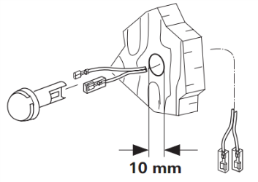

Figure19
Make sure that the external temperature sensor is always mounted on the vertical wall. It must be surrounded by free-flowing air.
Drill a hole 10 mm in diameter. The single-wire terminal passes through the opening from the back and connects the end of the cable to the sensor with an insulating plug (without observing polarity). Slide into the external temperature sensor and connect the two ends of the cable with two insulating connectors to the heater electronic devices (if necessary, extend the cable to a maximum length of 10 meters, 2 *0.5 mm 2 cable). The external temperature sensor provided must always be connected, otherwise the heater will switch to failure.
Install LCD switch
Gas heater must be operated by special liquid crystal switch. See the relevant instructions for details.

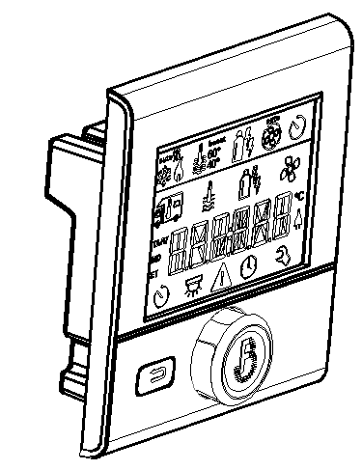

Figure20

Electrical Connection
Lay wires to avoid scratches. If there are sharp edges, such as metal panel threading, please use lead bushing or edge protection accessories. Connector cables shall not adhere to or touch metal surfaces, exhaust pipes or hot air pipes.
The electrical connection socket is located below the controller cover. The controller cover can be removed by pressing and sliding along the arrow at the same time. When removing or installing the controller cover, make sure that the connecting cable is not pulled out or squeezed.
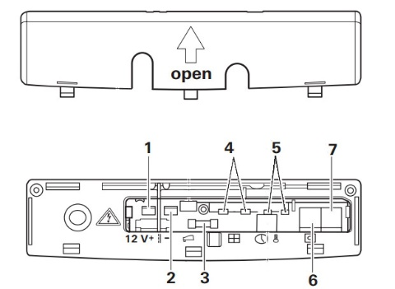

- DC12Vpositive electrode
- DC12Vnegative electrode
- Fuse
- Window Switch
- External temperature sensor
- 7-control switch
Pic21
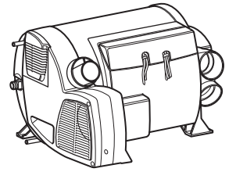
When the window switch is not installed, the short wiring cannot be removed. All cables connected to the heater should be poked in a sagging direction. This prevents condensate from slipping off the connector cable and entering the heater.

Figure22
Connector cables and plugs must not be subjected to force.（Pic19），Tie connector cables and fasten them to the housing with straps to eliminate tension.
All cables must be firmly connected together. They should not be loosened or disconnected by vibration, resulting in fire hazards!
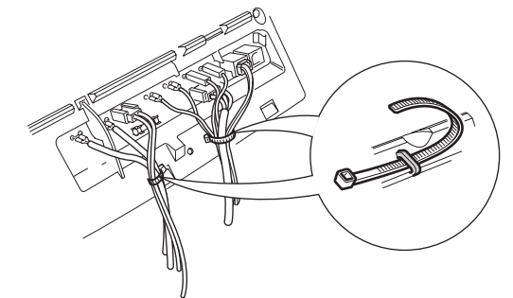

Pic23
DC12V Power
The electric circuit, switch and control equipment of the heater must be located in a position that will not adversely affect its operation under normal working conditions. The heater has reverse polarity protection. If the controller is not properly polarized, the LED indicator will not work.
In order to provide the best power supply, the heater must be connected to the on-board power supply (or battery) protected by fuse (10A) with a 2 x 2.5 mm 2 cable (2 x 4 mm 2 for a length exceeding 6 m). If necessary, the voltage drop of the power supply line must be considered. Connect the negative pole line to the main grounding. If the heater is directly connected to the battery, the positive and negative lines must be protected. Do not connect other power-consuming equipment.
Electrical connection of oil pump 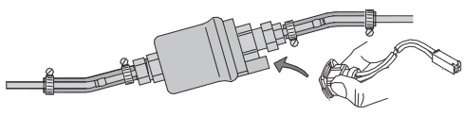

Make sure the plug is firmly connected.

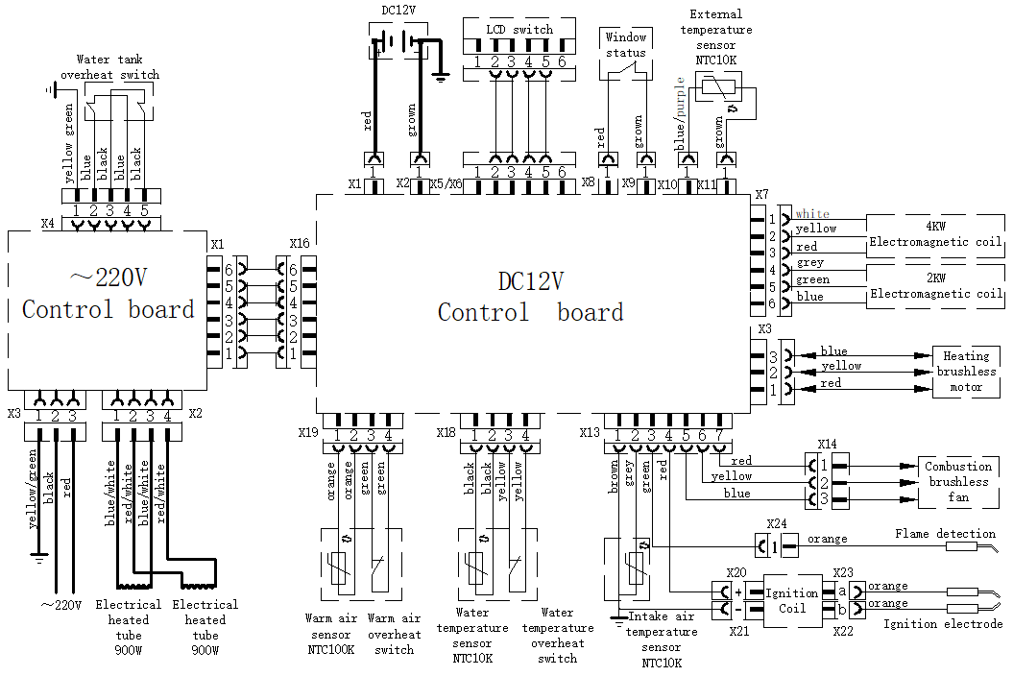
图20
6. Operating precautions

Heaters are not allowed to operate during refueling or in enclosed spaces (enclosed parking lots, repair shops or ferry compartments). Check regularly whether the intake and exhaust pipes are in good condition and the fixing is reliable, especially after a trip. Also check the fixing of intake and exhaust pipes and smoke caps.

When black smoke is found, the company's authorized professionals are requested to carry out the inspection. Ensure that the exhaust pipe and intake pipe at the smoke exhaust cap are free from blockages such as snow, ice and leaves. Warm air outlet and circulating air inlet are unobstructed to avoid overheating of heater. In the case of overheating, the overheating switch will immediately cut off the fuel supply.

If the fuel heater wants to meet the heating needs in driving, it should install safety shut-off device.

★If there is no safety shut-off device, the heater must be turned off before driving.

12V Fuse

Replacement with exactly the same fuse T20A is allowed only.
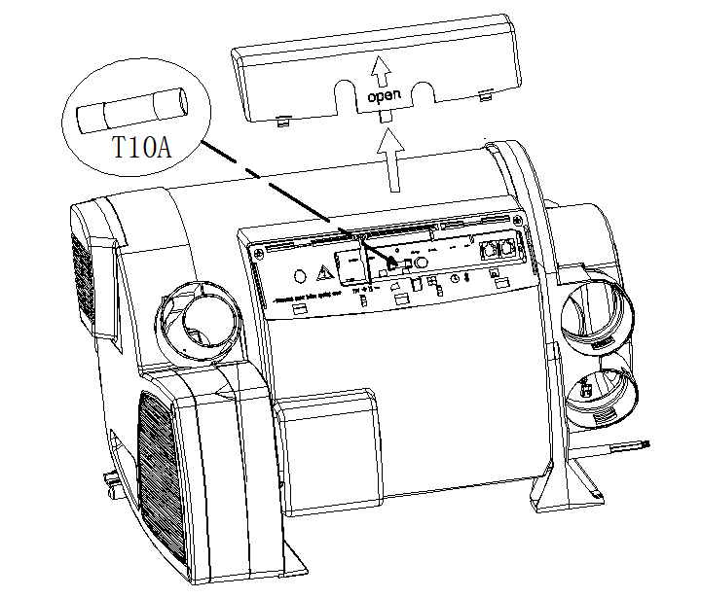

Figure25

～220V Fuse

★Fuses and wiring harnesses must be replaced by professionals authorized by the Company.

★All power supply must be disconnected before opening the control housing.

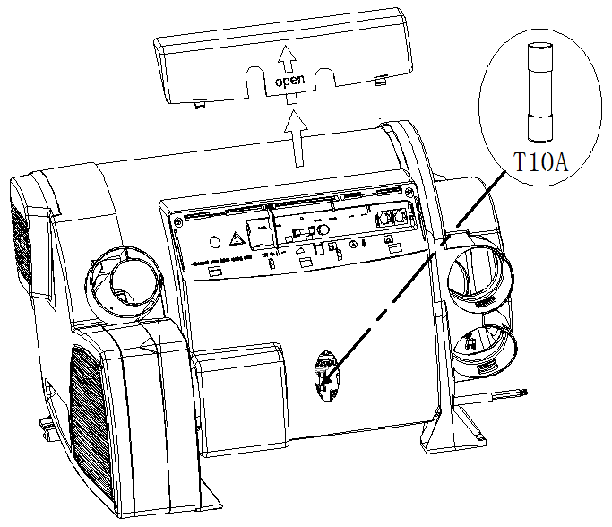
Fuse Specification: T10A Slow Fuse

Figure26

～220V Overheat protection
The municipal electric heating function has a mechanical overheating protection switch. If the 12V power supply is interrupted during or after the heating process, the excess heat of the heater will trigger the overheating protection switch.

When the temperature of the water tank decreases, disconnect the power supply from 220V, remove the cover of the controller, and reset the overheat protection switch by pressing the reset button by hand.。
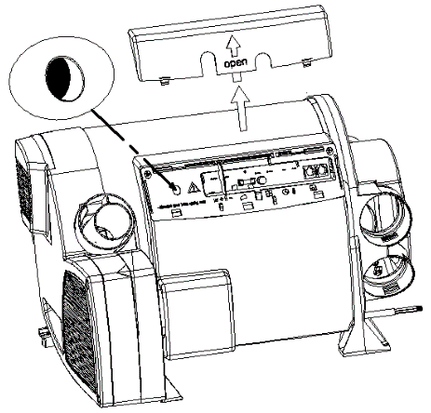

Figure27

7. Operational instructions

Please read the instructions carefully before operation.

Start-up heater

Use special liquid crystal switch to operate.

Fuel oil, electricity, mixing mode, heating water tank or unheated water tank for main engine heating are set according to need.

Check the power supply capacity of RV camps, and choose the operation mode of 900W (3.9A) or 1800W (7.8A) accordingly. -- Check whether the smoke exhaust cap is unobstructed

-- Open Liquefied Gas Tank Switch Valve

-- The tank is full of water when needed

Filling of water

Check whether the relief valve/drain valve is closed.

——Turn on the pump power supply (main gate or pump switch)

——Open the hot water tap in the kitchen or bathroom and keep the valve open until the air in the container is discharged and the water is continuously discharged.

——In the absence of water heater heating, if only the cold water system is in operation, the water heater will also be full of water. To avoid frost damage, the water heater must be drained through a safety/drainage valve, even if it is not running.

——In the case of frost, the frozen residual water can prevent filling. The water heater can thaw (no more than 2 minutes) if it is turned on for a while. The ice can be thawed through the inside of the heater.

——If the heater is connected to the central water supply system (rural or urban water supply system), a pressure reducer must be used to prevent pressure exceeding 2.8 bar (0.28 MPa).

-- Open the circulating pump

-- Open the hot tap in the kitchen and bathroom until the air is exhausted and the water tank is filled, and the water is not interrupted.

Turn off the heater

-- Use special liquid crystal switch to operate.

-- After the heater is closed, the combustion-supporting fan and heating fan will continue to work for several minutes according to the temperature of the furnace body.

In case of freezing danger, it is necessary to ensure that the water tank is emptied.

-- Close the circulating pump

-- Turn on the hot tap in the kitchen and bathroom

Heater drainage

——If the RV is not used during the frost. The heater must drain the water.

——Turn off the power supply (main power supply or pump switch) of the pump unit.

——Turn on the hot tap in the kitchen and bathroom.

——In order to check the effluent, the safety/drainage valve (user-fitted, for manual emptying of the water tank) is installed. The anti-freeze valve cannot ensure that the water tank is completely emptied. Place a suitable container under the drain tank.

——Open the safety/drainage valve.

——The heater will be discharged directly to the outside through the safety/drainage valve. Check whether all water in the heater has been discharged into the container through the safety/drainage valve. Claims for damage caused by frost shall not be filed during the warranty period.

★The 10L bucket can be used for water inspection to ensure that the water tank is empty.

The valve of liquefied gas tank must be closed before heater is not used for a long time or running.

Maintenance/repair/cleaning

-- The device can only be repaired and cleaned by experts.

-- Maintenance, repair and cleaning cannot be done by children.

-- With new equipment, or the equipment has not been used for some time, thoroughly flush all hot/cold water hoses before use.

8. Failure
8.1 General Failure Handling
8.1.1 During the use of the heater, it may appear that it cannot start normally or turn off it after starting and is in the fault lock state. At this time, the heater can be turned off for more than 5S and restart.
8.1.2 The heater may cause circuit failure due to the following reasons: the connector is rusted, the poor contact, the plug is incorrect, the wire or fuse is rusted, the battery pile is rusted, etc.
Pay attention to inspection, maintenance and prevent these phenomena from occurring during use.
8.1.3 When the following conditions occur, it can be handled and eliminated by the user:
●The heater does not start after the power is turned on and the LCD switch screen does not light. The reason is that the fuse is open, or the wiring is wrong. In addition, check whether the plug on the LED switch lead wire is properly connected to the host.
8.2 Fault Lock Status
8.2.1 The fault generated by the heater is indicated by the fault code on the LED switch.
8.2.2 The faults can be eliminated according to the methods
Listed in Table 2.

Fault Lock Status Debug Method
Fault Code | Fault Name | Fault Debug  Method
10 | Overvoltage fault | - Check vehicle power supply system
11 | Under voltage fault | - Check vehicle power supply system
21 | Warm air outlet temperature sensor disconnection | - Check if the sensor is in good condition
22 | Warm air outlet temperature sensor short circuit | - Check if the sensor is in good condition
23 | Water temperature sensor disconnection | - Check if the sensor is in good condition
24 | Water temperature sensor short circuit | - Check if the sensor is in good condition
25 | External temperature sensor disconnection | - Check if the sensor is in good condition
26 | External temperature sensor short circuit | - Check if the sensor is in good condition
27 | Combustion support temperature sensor disconnection | - Check if the sensor is in good condition
28 | Combustion support temperature sensor short circuit | - Check if the sensor is in good condition
31 | Combustion failure | - Check gas supply system  - Check whether combustion inlet and outlet are  blocked  c. Check the Ignition coil, ignition electrode,  d. Flame sensor
32 | Combustion failure | - Check gas supply system  - Check whether combustion inlet and outlet are blocked  - Check the flame sensor
33 | Flame sensor fault | - Check the flame sensor lead wire  Check the flame sensor
41 | Warm air outlet overheats | - Check whether air outlet is blocked
42 | Warm air overheats switch protection | - Check whether air outlet is blocked  b. Check warm air overheat switch
43 | Water overheat | - Check whether water depletion in the tank  - Check if the sensor is in good condition  - Check whether air outlet is blocked
Fault Lock Status Debug Method
Fault Code | Fault Name | Fault Debug Method
44 | Warm air overheats switch protection. | a. Check whether air outlet is blocked.  b. Check warm air overheat switch
45 | Overheating fault | a. Check whether air outlet is blocked  b. Check water temperature sensor  c. Check warm air sensor
51 | Communication fault | a. Check interconnecting cable
61 | Oil Pump Break | a. Check whether the oil pump lead is damaged or not b. Check whether the connection of oil pump leads is reliable.  c. Refurbishment oil pump  d. Replacement of motherboard
62 | Short circuit of oil pump | a. Check whether the oil pump lead is damaged  b. Check whether the connection of oil pump leads is reliable  c. Refurbishment oil pump  d. Replacement of motherboard
63 | Circuit Breaking of Electric Plug | a. Check the power supply voltage  b. Check the resistance of the plug at room temperature (0.2/12V)  c. Cleaning up Carbon Accumulation in Electric Plug  d. Replacement of motherboard
65 | Electric plug without drive | a. Replacement of motherboard
81 | Combustion support fan disconnection | a. Check combustion air blower
82 | Combustion support blower boot failure | - Check the blower motor lead wire  - Check combustion air blower
83 | Combustion support blower spindle speed too low | a. Check combustion air blower motor
84 | Warm air blower motor disconnection | a. Check warm air blower motor
85 | Warm air blower motor boot failure | - Check the blower motor lead wire  - Check warm air blower motor
86 | Warm air blower spindle speed too low | - Check warm air blower motor
110 | Window alarm | a. Check window switch interconnecting cable
120 | Low voltage alarm | a. Recommended charging
220 | 220V Connectionless | a. Check AC 220V power supply system
9. Operational Precautions
●Initial Installation
–The heater is installed for the first time. In order to completely eliminate the air in the fuel supply system and make the fuel pipeline full of fuel, a separate pump function is specially designed. See LCD switch instructions for details.

–Rinse the water tank with clean water before the heater is first installed and used. When the heater is not in use, please empty the water tank so as not to freeze the water tank. The company is not liable for damage to the water tank caused by freezing.

-- Open the circulating pump

-- Open the hot tap in the kitchen and bathroom until the air is exhausted and the water tank is filled, and the water is not interrupted.
-- The heater should be tested before use. During the trial run, all connections should be carefully checked for leaks and security conditions. If there is smoke emission, abnormal combustion noise or fuel gas odor, the heater should be closed and the fuse should be pulled out so that it cannot operate. It can only be used after being inspected and repaired by professionals.
–When the heater is first used, it may emit odor in a short time. This is normal in the first few minutes of operation, and it does not mean that the heater is out of function.
●Quarterly Maintenance
–Before each heating season, the following maintenance work must be carried out by professionals:
Check whether the air inlet and outlet are contaminated and foreign matter.
Clean the outside of the heater.
Check for corrosion and loosening of circuit joints. Check whether the intake and exhaust pipes are blocked or damaged.
Check the fuel line for leakage.
●Long-term shutdown
–When the heater is not used for a long time, it should be run every 4 weeks for about 10 minutes each time to prevent mechanical parts such as solenoid valves and combustion-supporting air fans from failing to function (freezing).
–The inlet and outlet of heater must be kept free of blockage and dirt, so that the warm air duct is unimpeded, in order to prevent overheating failure.
–When replacing low-temperature fuel, the heater should run for at least 15 minutes to fill the fuel system with new oil.
●Heater life
–The heat exchanger of the heater cannot be used for more than 10 years. Upon expiration, it must be replaced by genuine parts and replaced by the heater manufacturer or its authorized agent.
–When the exhaust pipe of the heater discharges combustion exhaust gas for 10 years, it must be renewed with genuine parts.
●Other considerations

–Water tanks must be cleaned regularly, at least twice a year.
–In the process of transportation and storage, the ambient temperature of heater should not exceed the range of - 40 ~85 ~C in order to prevent damage to electronic components.
–Only authorized customer service stations are allowed to install and repair heaters, and non-original parts are prohibited to avoid danger.
–The manufacturer is not responsible for the maintenance of the heater due to the failure to install and operate in accordance with the regulations.
–The heater must be turned off before refueling.
–When welding automobiles, the positive pole of the heater should be removed from the battery and grounded to prevent damage to the controller.

10. Packing list
Packing list
No. | Name | Specifications | No. | Order code
1 | Instructions | YFJH-6E/1C main engine | 1 | 22020203400
2 | Heater mainframe | YFJH-6E/1C | 1 | 4T300612C01
3 | Cross head tapping nail | ST5*25 | 5 | 12050016100
4 | 12VPower cord | 4m | 1 | 12031101600
5 | External temperature sensor | NTC10K | 1 | 31011102100
6 | External temperature sensor lead | L=4m | 1 | 12031100500
7 | LCD Switch | MNB-V-FY | 1 | 31011104400
8 | Instructions | LCD Switch MNB-V-FY | 1 | 22020202600
9 | Cross head tapping nail | M3*10 | 4 | 12050002400
10 | Cross countersunk head and flat tail self-tapping nail | M3*6 | 1 | 12050016000
11 | LCD Switch Lead | 6m | 1 | 12031101500
12 | Controller Cover | 260×75×22 | 1 | 12021100900
13 | Cross head tapping screw | ST5×16 | 4 | 12050007300
14 | External wire clamp sleeve connector | G1/2-φ10  G1/2-φ8 | 2 | 12011104300
15 | cable ties | 4×200 | 10 | 21990000000
16 | Intake and exhaust body | φ110×108 | 1 | 12011101900
17 | Intake and exhaust hood | φ110×34 | 1 | 12021102000
18 | Gasket | φ104.5×φ73×2.4 | 1 | 12041101800
19 | Clamp | φ55 | 2 | 31011102700
20 | German clamp | 70-90 | 2 | 12050200700
21 | Fixed clip for intake pipe | φ80 | 1 | 12021102700
22 | Cross head tapping screw | ST3.5×25 | 9 | 12050015600
23 | Exhaust pipe | φ55/φ50×950 | 1 | 12060007700
24 | Intake pipe | φ80/φ76×1000 | 1 | 12060007800
25 | Vent | CFK-φ60-Ⅲ(Flexibility adjustable) | 4 | 31011104700
26 | Pressure relief valve | 0.5MPa | 1 | 12501101000
27 | Antifreeze valve | 1～4℃ | 1 | 31011106600
28 | German clamp | φ50-φ70 | 4 | 12010005100
29 | Bellows snap | φ60 | 4 | 12021102600
30 | Oil Pump Assembly | YB-Ⅰ-12V Buffer | 1 | 33000007600
31 | Fixed jacket of oil pump | φ32×29 | 1 | 12990007300
32 | Oil Filter Assembly | CX0708(4100)Aluminum base and combination cushion | 1 | 12500005400
33 | Tubing joint | φ3.5/φ9.5 L=40 | 3 | 12060003900
34 | Tubing joint | φ4.1/φ10.5 L=40 | 4 | 12060003800
35 | Tubing clip | φ8～10（9） | 5 | 12010004300
36 | Tubing clip | φ9～11（10） | 9 | 12010004200

Packing list
No. | Name | Specifications | No. | Order code
37 | Pipeline (oil pump to main engine) | Nylon pipeφ4×1 L=6800 transparent | 1 | 12060004200
38 | Pipeline (pump to tank) | Nylon pipeφ5×1.5 L=1200blue | 1 | 12060004600
39 | Unidirectional valve | 4*36 | 1 | Encoding
40 | Oil pump wiring harness | L=6800 | 1 | 12031200300
41 | Self-drilling and self-tapping screw | ST5.5×30 | 3 | 12050003000
42 | Suction pipe | XYG-Ⅱφ5×600 | 1 | 31000000500
43 | Reducing T | 10-6-10 | 1 | 12020015700
44 | Mini Clamp | 12-14 | 2 | 12010004600
Note: Items 16 to 44 are separately packed in attachment boxes. Outside the packing list are optional accessories, which can be selected by contacting us.

